Amend\View a Customer

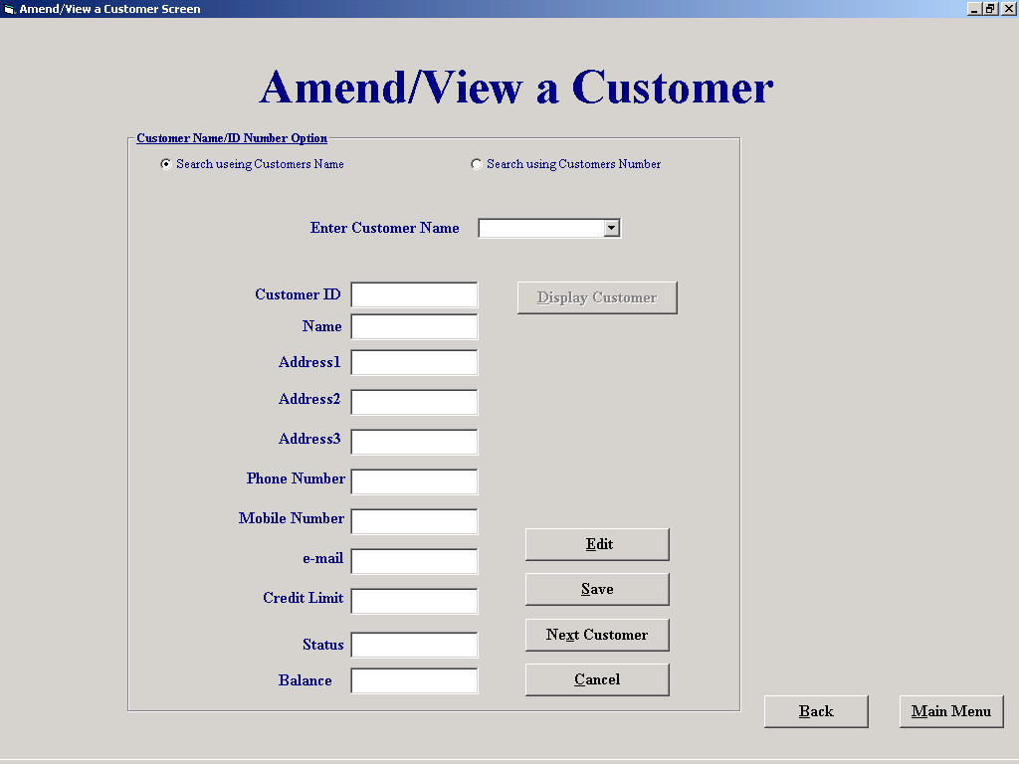

Purpose of this screen
This form allows the user to select a customer either by picking a customer ID from a drop down list, picking a customer name from a drop down list or by entering part of a name and searching through any names that match the criteria The Customers details can then be saved or amended. If a customers details are amended they will be temporarily stored in the associated tag of the relevant text box until the save command is selected. If the cancel command is selected then all amendments not saved will be deleted

How to get to the screen
Select “File Maintenance” button on the main menu, then the “Customer File processing on the File Maintenance menu followed by Amend View Customer Button

How to use the screen
- A customer can be searched for by name or number
- If you wish to select to search for a customer by name (this is the default and is selected automatically when the screen opens) select the “Search using Customer’s Name “ option
- Then either
- View a list of all possible names of customers who have accounts with the company by selecting the down arrow on the right of the data input box marked “Enter Customer name”
- Then select a name by clicking on it (To allow a quick search the names are sorted alphabetically)
- When a name has been selected it will appear in the data input part of the input box
- Or
- Alternatively type any part of the name in to the data input part of the input box marked “Enter Customer name”
- If you wish to select to search for a customer by ID number select the “Search using Customer’s Number “ option
- View a list of all possible ID numbers of customers who have accounts with the company by selecting the down arrow on the right of the data input box marked “Enter Customer name”
- Then select a name by clicking on it
- When a ID number has been selected it will appear in the data input part of the input box

- Select the “Display Customer” Button
- The ‘first match’ of the customers details will be displayed in the data input boxes allowing you to confirm the details are correct either from your own knowledge of the customer or by asking the customer to confirm his address etc
- If you have selected the “Search using Customer’s Name “ option and there is more than one match of the name entered then a box will appear with “The number of customers matching the search criteria” shown. There are two buttons on this box “Display Next” and Display Previous”. Selecting either buttons allows you to move through the customers displaying their full details.
- Selecting the “Edit”(alt-E) button allows you to make changes to the customer displayed on screen
- Selecting the “Next Customer”(alt-x) button allows to select another customer to view or amend (Note: you do not need to save the changes that you have presently displayed as these can be saved fore you exit the screen)
- Selecting the “Cancel”(alt-C) button clears all unsaved changes

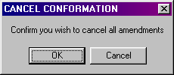

- Selecting the “Save” (alt&S) allows you to save all the customers records that you have altered

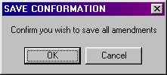

- Selecting the “Main Menu”(alt-M) brings you to the Main menu if there is unsaved data in the screen you will be prompted to save it with a message box

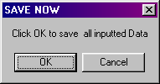

- Selecting the “Back”(alt-B) button brings you to the screen that you were in prior to this one

